-

**Literacy**

This half term, we will be reading The Gingerbread Man, Goldilocks and the Three Bears and the Little Red Hen. We will read each book over 2 weeks and will be talking about the characters, learning vocabulary and key phrases, ordering pictures from the story and finally combining everything we have learned together, to act out the story.

In phonics, we are continuing to follow the Little Wandle phonics scheme. Each week we will introduce a different initial sound and play games focussed around words which start with that sound.

In writing, we will be drawing pictures, making writing patterns and continuing to practice writing our names.

**Maths**

In maths we follow the White Rose Scheme. This half term, we will be looking at shapes and talking about their similarities and differences. We will then use what we know about shapes to create pictures and representations.

We will also be introducing the vocabulary ‘fewer’, ‘more’ and the ‘same’ when discussing the quantities in a group. We will begin to subitise numbers 1, 2 and 3 and recognise these amounts without counting e.g. on dominoes or on a dice.

**Personal, Social and Emotional Development**

We will be encouraging the children’s independence skills and showing them ways to put on their coats independently. For the children who can already do this, we will be helping them to learn to zip up their coats on their own. Please practice this at home too!

The children will be playing lots of games which encourage them to take turns and share. This is a skill that the children were developing last half term, and they are all making fantastic progress.

**Traditional Tales**

**Spring 2 2025**

**Acorn Class**

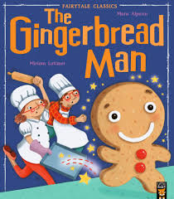 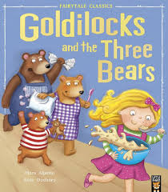 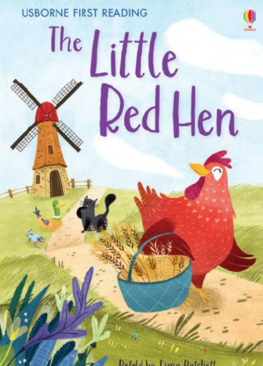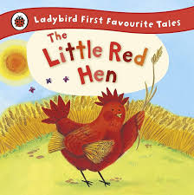

**Physical Development**

We are continuing to develop the children’s gross motor skills and core strength through activities outside and inside. The children will be travelling in different ways and moving their bodies in different patterns.

The children will also be developing their fine motor skills, through using playdough, tweezers, threading and peg games.

**Understanding of the World**

Last half term, we learned all about the winter season. This half term, the children are going to learn about spring. We will be spotting the signs of spring and noticing the differences and similarities between the two seasons, winter and spring.

**Communication and Language**

We will be learning lots of new language and vocabulary through our stories of the week. The children will also be using different actions to help them remember the new vocabulary. The children will also be listening carefully to stories and information and will answer questions about what they have heard, using full sentences.

**Expressive Arts and Design**

The children will be taking part in lots of creative activities this half term. We will be singing nursery rhymes, exploring different musical instruments, making pictures, drawings and paintings of representations of the characters from the stories of the week. We are also going to be baking our own gingerbread men!